**Title: How to create azure vm using Jenkins pipeline**

* **Why Should i Write a Technical Blog**:

When my manager asked me to do this task, after reading many documentations and searching on many different websites, I did not find complete information about this task anywhere, for that I also took the support of YouTube, but I did not get complete information there, but on the basis of the information received, I completed each part of the task under the guidance of the senior. Completed the entire hour well .After finishing today I felt to help many people by writing documentation about this in a good complete form so I am writing this complete blog which will surely benefit many people.

* **Task description:**

In this task we are going to learn how to create vm through the jenkins Pipeline, we can create one or more vms at a time with help of azure CLI code.

* **Prerequisite:**

1.You should have installed Azure cli on your system.

2.You should have azure account with permission owner or contributor.

3 You should have installed and configure jenkins on your system.

After all installation & configuration now you are ready to go…!!

* **Stepwise performance:**

**1**.To start jenkins and install Azure CLI & Azure credential plugins.

**2.** Login your azure account open azure CLI create a service principal perform following command in azure cli 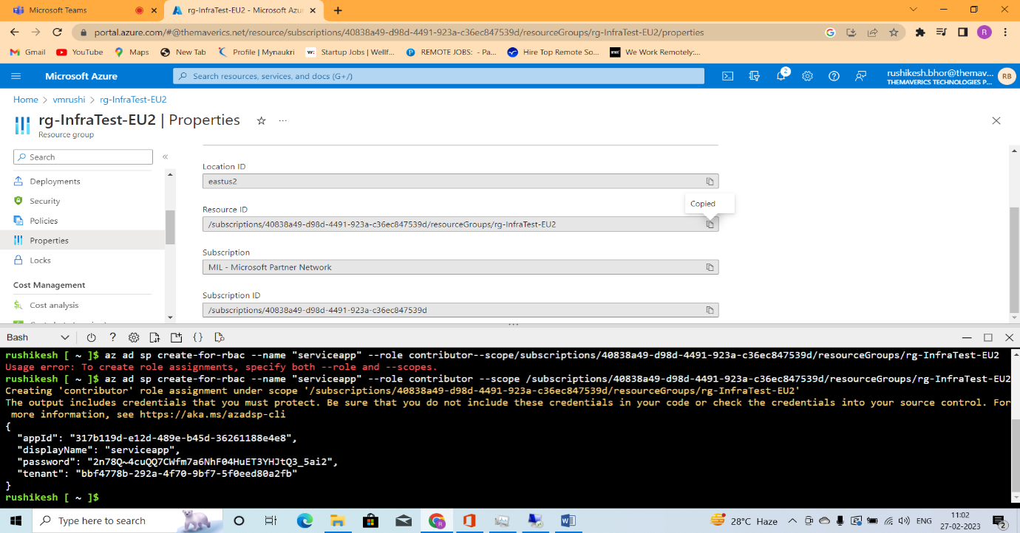

*Note: please ignore first line of command*

az ad sp create-for-rbac - -name “serviceapp” --role contributor –scope “paste resource group location”

you get resource group location click on resource group -> select resource group -> properties ->Resource ID copy path then paste to above command

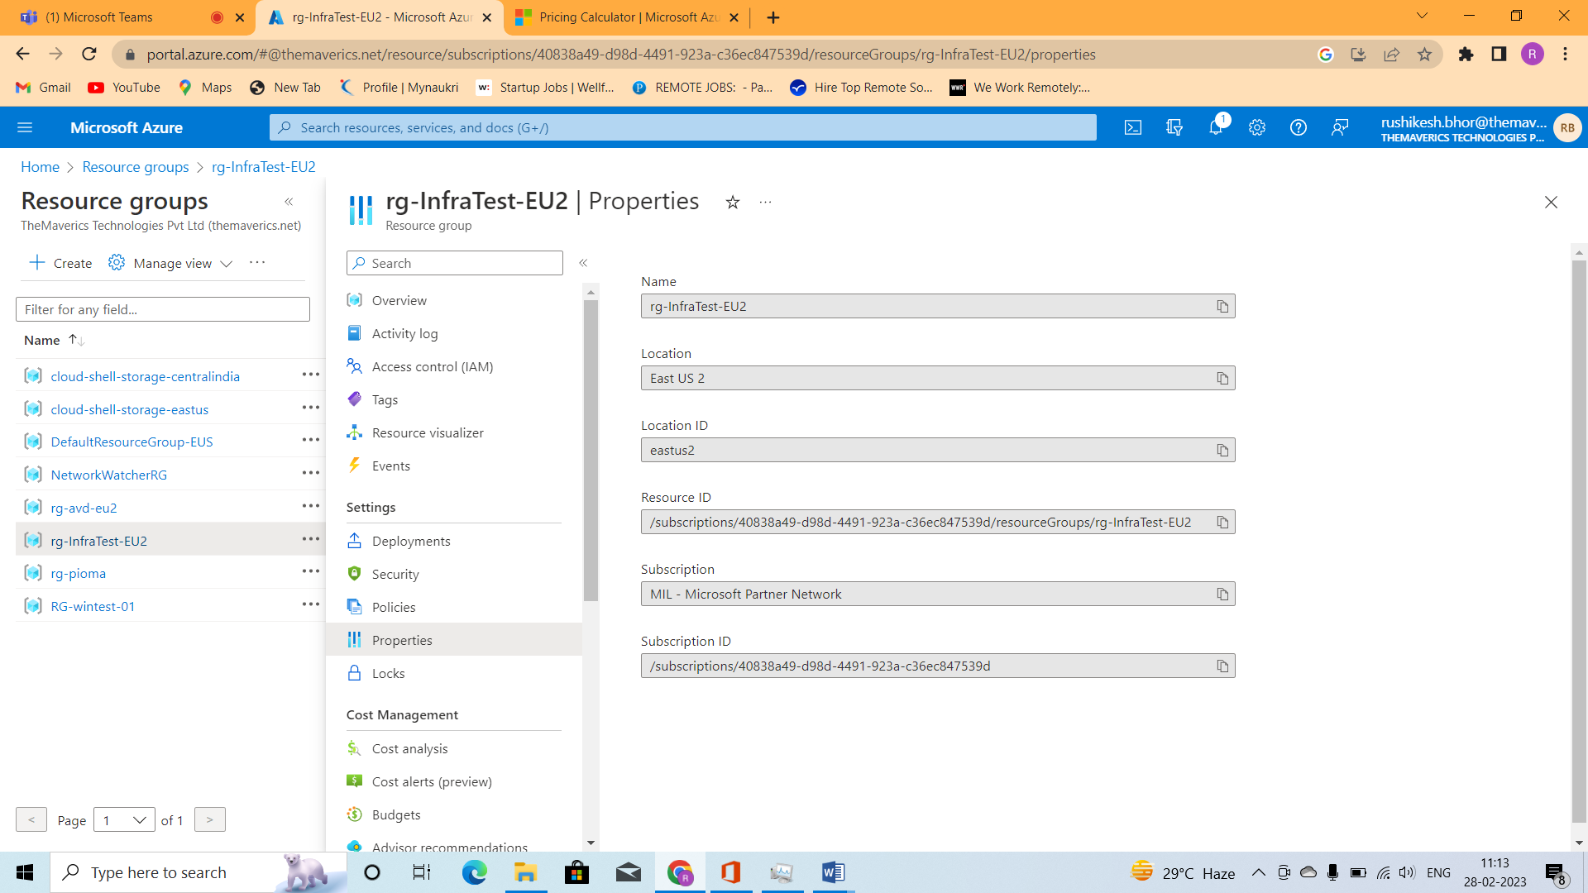

We get output in following form

Appid = client id

Displayname

Password = secret

Tenant = tenant id

* **Information about output term**:

**Subscription ID**: This is the unique identifier for your Azure subscription. It can be found in the Azure portal under "Subscriptions".

**Tenant ID**: This is the unique identifier for your Azure Active Directory (AAD) tenant. It can be found in the Azure portal under "Azure Active Directory" -> "Properties".

**Client ID**: This is the application ID for the service principal that will be used to authenticate with Azure.

**Client Secret**: This is the secret that is associated with the client ID.

**3**. Again go to jenkins go to manage jenkins ->manage credential ->system ->global credential ->add credential fill some detail we get from after creation of service principal in azure cli

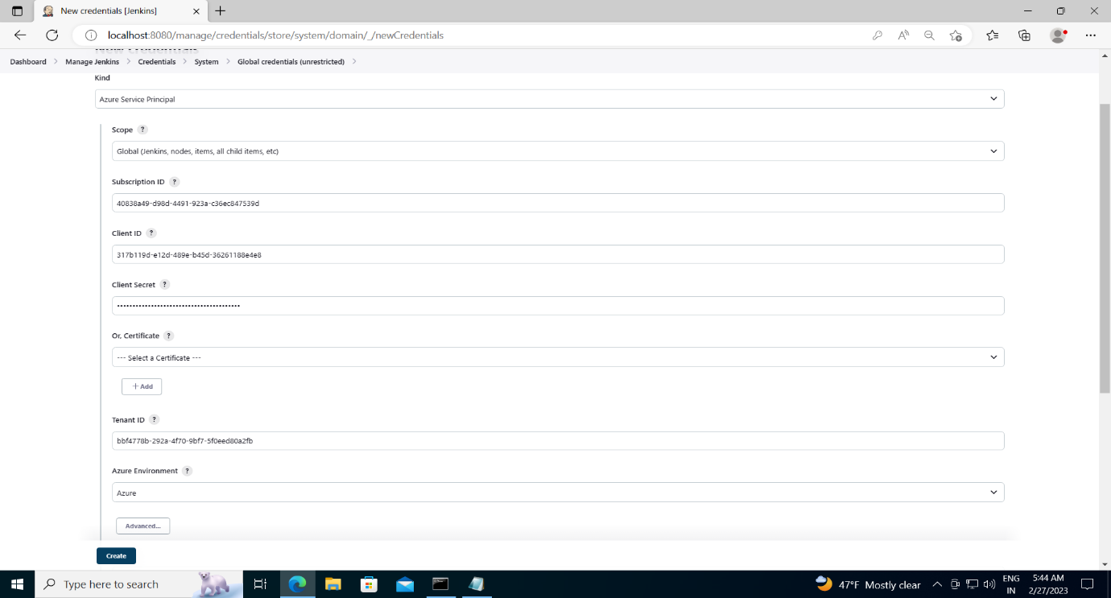

**4**. In jenkins dashboard select new project then select freestyle project

**5**. Then under build environment ->user secret text or file -> add ->Microsoft azure service principal

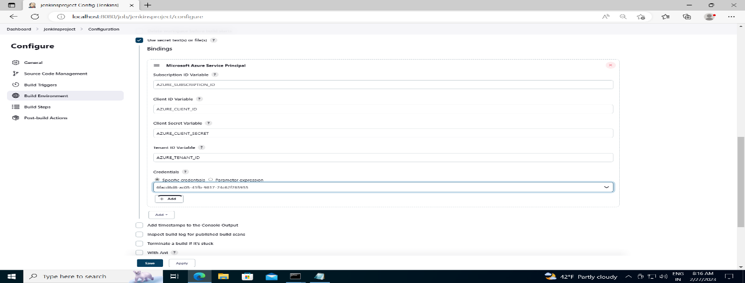

**6**. Next select build step ->add build step -> select last option azure cli

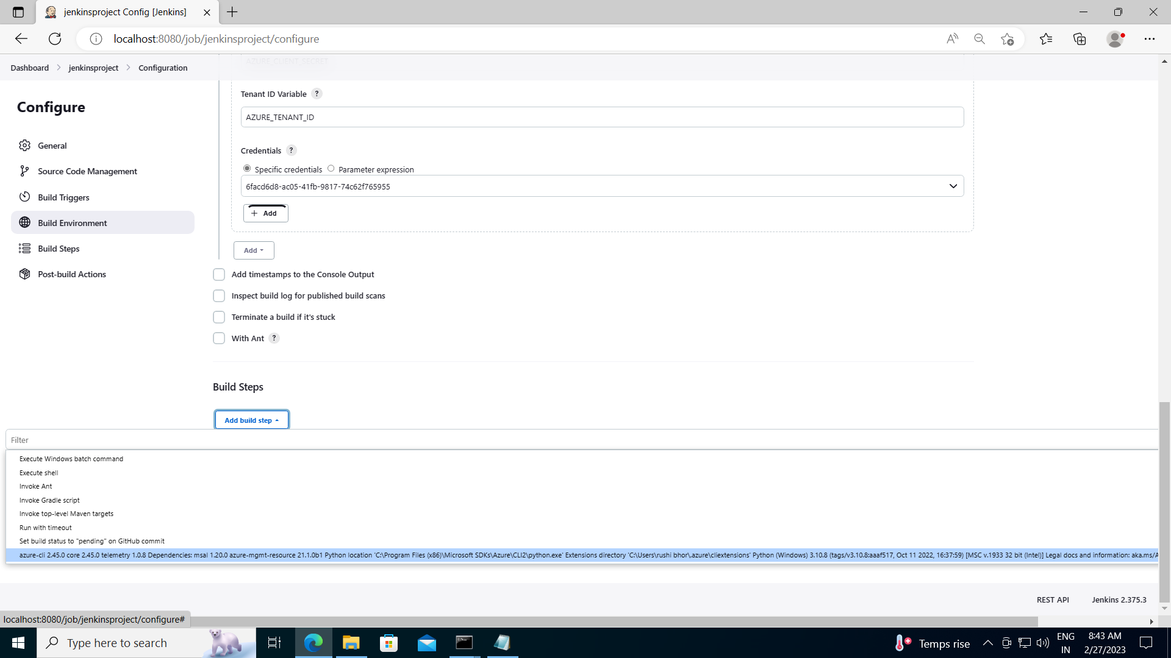

**7.** In service principal select key of credential and add azure cli script of vm in command section

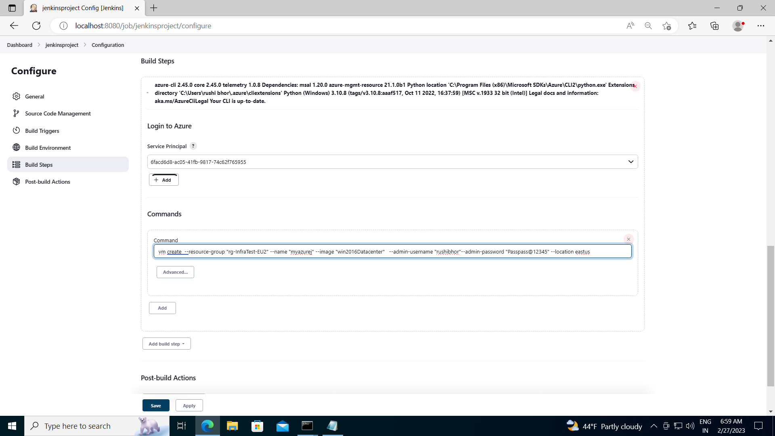

**8**. last step save all these steps and run job

After completing all these steps, you should go to your azure account in the virtual machine section, you will see a virtual machine created in the azure account with the same name as the machine created in it Jenkins pipeline.

That's how I completed my task successfully.

I would like to thanks to Sir for giving this challenging task. While doing this task, I learnt a lot of things related to Azure, jenkins.

If you have any doubt or suggestions you're most welcome, just DM me or can ask in Comments.